PRACTICAL LIST – AY: 2026- 27
Sr. no. | Title
4. | Title: CI/CD Pipeline Testing using Jenkins and Docker  Aim: To automate software testing through a CI/CD pipeline using Jenkins and Docker.  Software/Tools Required  - Jenkins  - Docker Desktop  - GitHub  - Selenium Test Script  - Java/Python  - Internet Connection  Procedure  - Install Jenkins and Docker.  - Clone a sample project from GitHub.  - Configure a Jenkins pipeline.  - Execute Selenium test cases automatically.  - Build and run the application inside a Docker container.  - Verify the build status and test execution report.  - Record the observations.  Expected Outcome: Automated test execution is successfully integrated into a CI/CD pipeline.  Result: CI/CD testing was successfully performed using Jenkins and Docker
Solution:
Step 1: Install Docker Desktop and Verify Installation
Download Docker Desktop, install it, sign in to your Docker account, and verify the installation using docker --version.
https://www.docker.com/products/docker-desktop
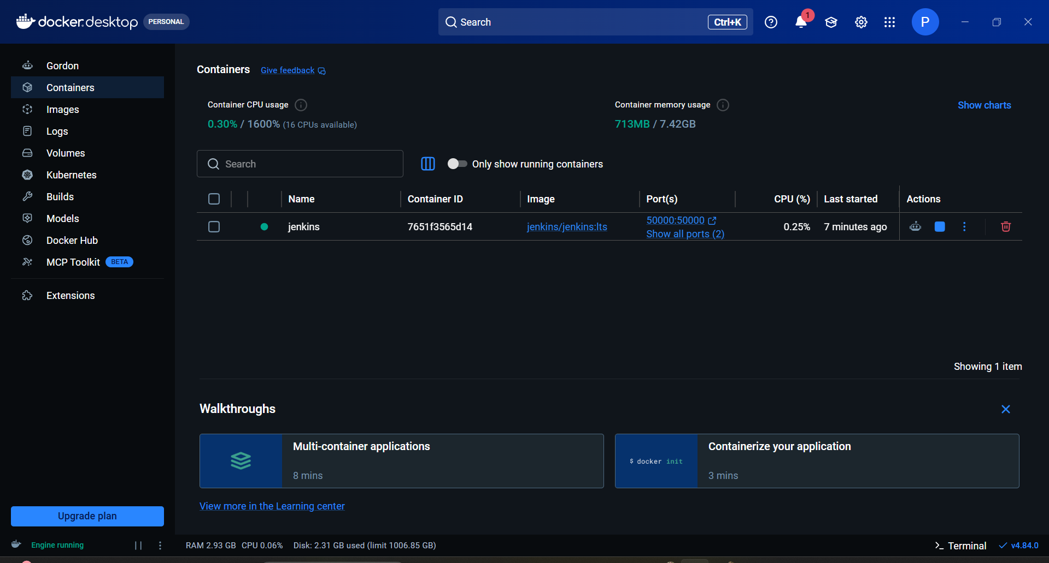
Verify Docker install : docker --version
Step 2: Run Jenkins Container
Run Jenkins using Docker. If port 8080 is unavailable, recreate the container using port 8081.
docker run -d -p 8080:8080 -p 50000:50000 --name jenkins jenkins/jenkins:lts
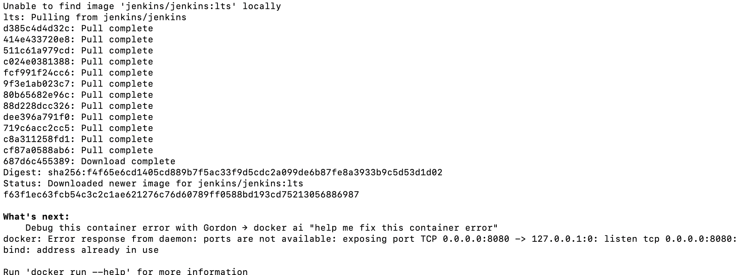
Check if Jenkins container is running: docker ps
If Container ID is blank then here jenkins is installed but 8080 port is not available So First remove jenkins and change port. 8080 to 8081.
docker rm jenkins

docker run -d -p 8081:8080 -p 50000:50000 --name jenkins jenkins/jenkins:lts

Now It's perfect working
Step 3: Retrieve Jenkins Password
Retrieve the Jenkins initial administrator password and save it securely.
docker exec jenkins cat /var/jenkins_home/secrets/initialAdminPassword

Step 4: Unlock Jenkins
Open Jenkins in the browser and enter the administrator password.
Set up Jenkins in the browser with http://localhost:8081 in browser

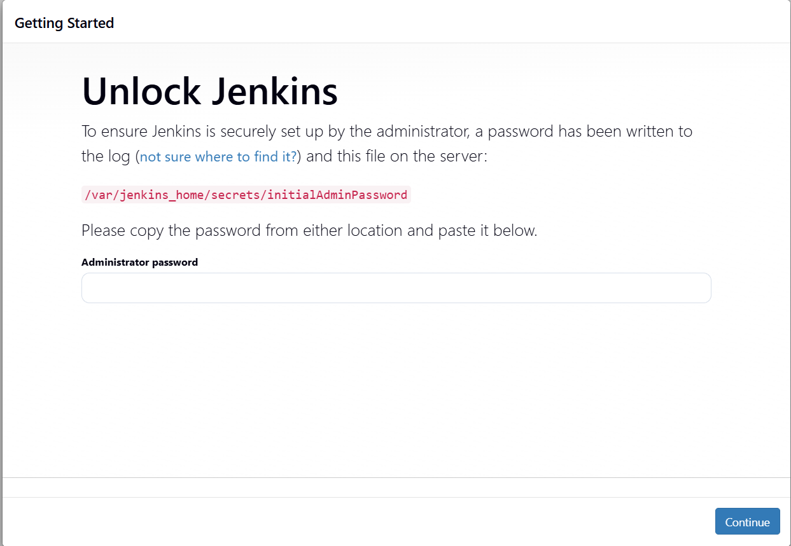

Enter password and Continue
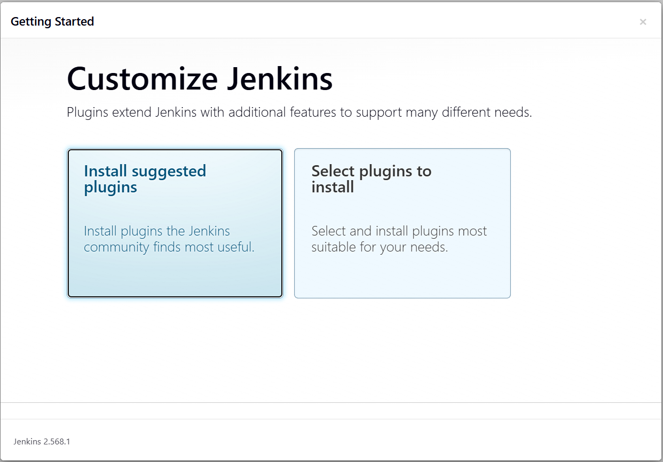Step 5: Install Plugins
Install the suggested plugins and wait for the installation process to complete.
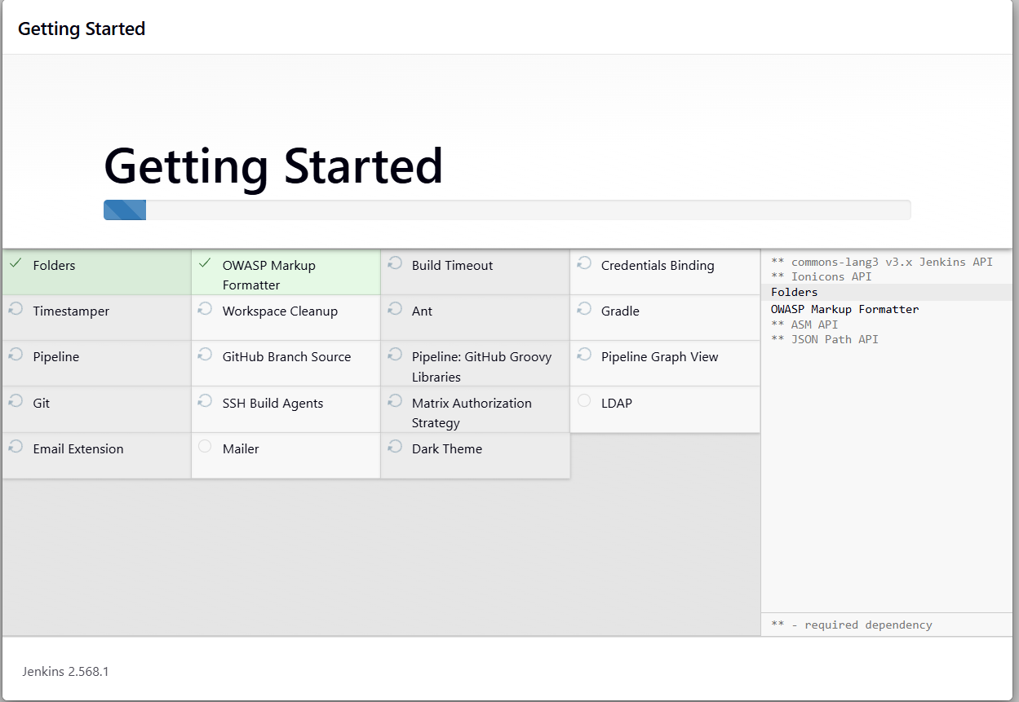
Wait until completion of the entire installation of all plugins and dependencies.
Step 6: Create Administrator Account
Create the first Jenkins administrator account and complete the setup wizard.
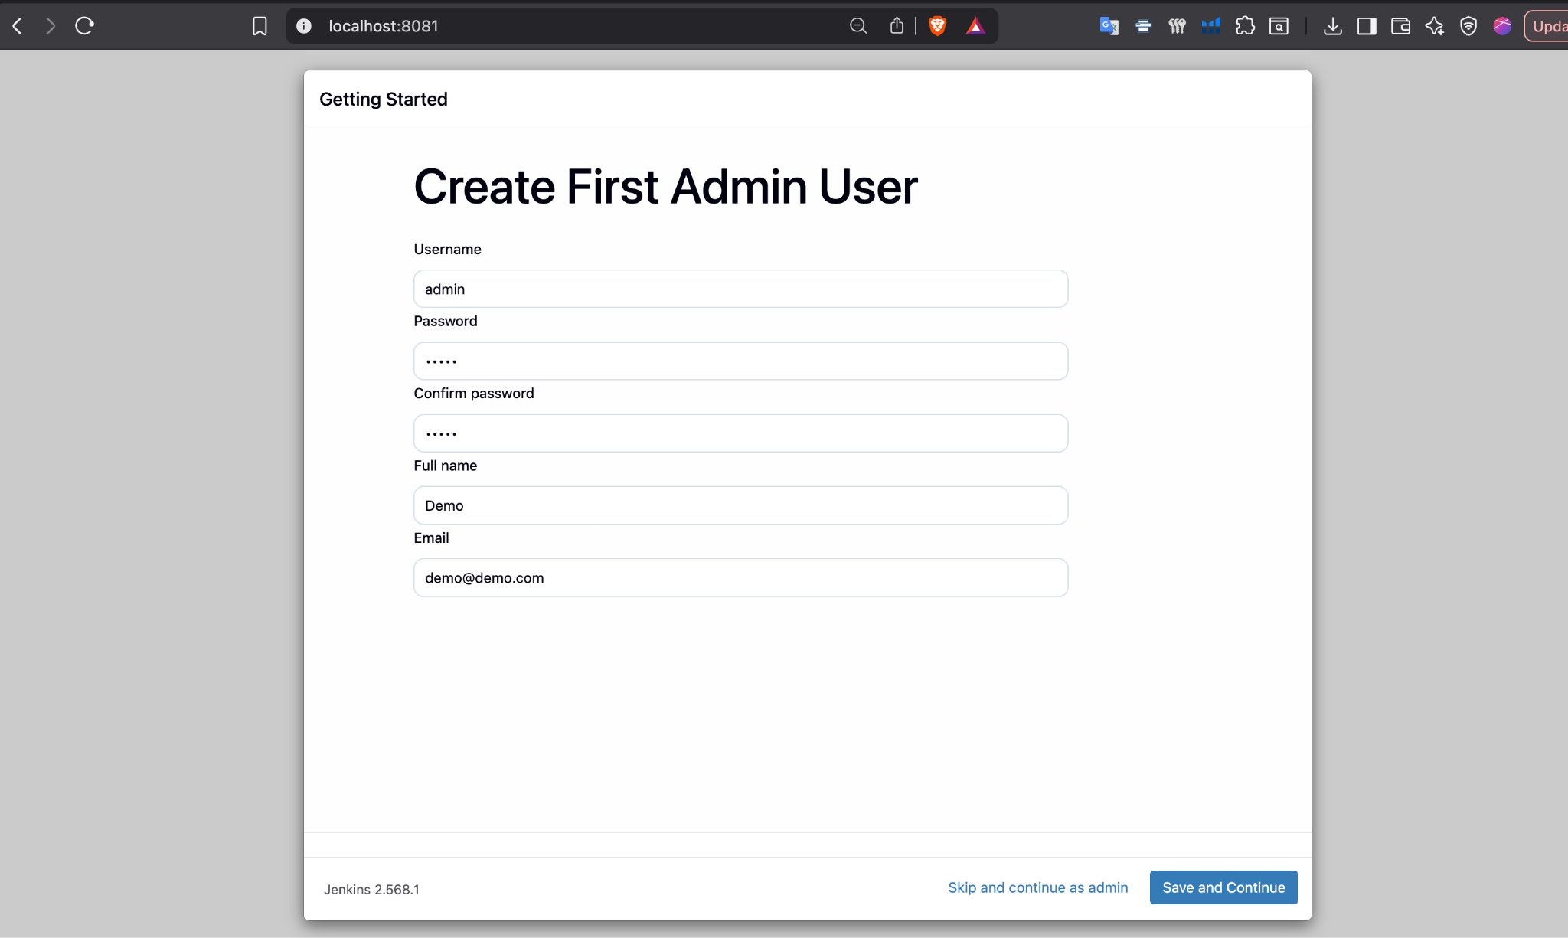
Enter required details and save & continue

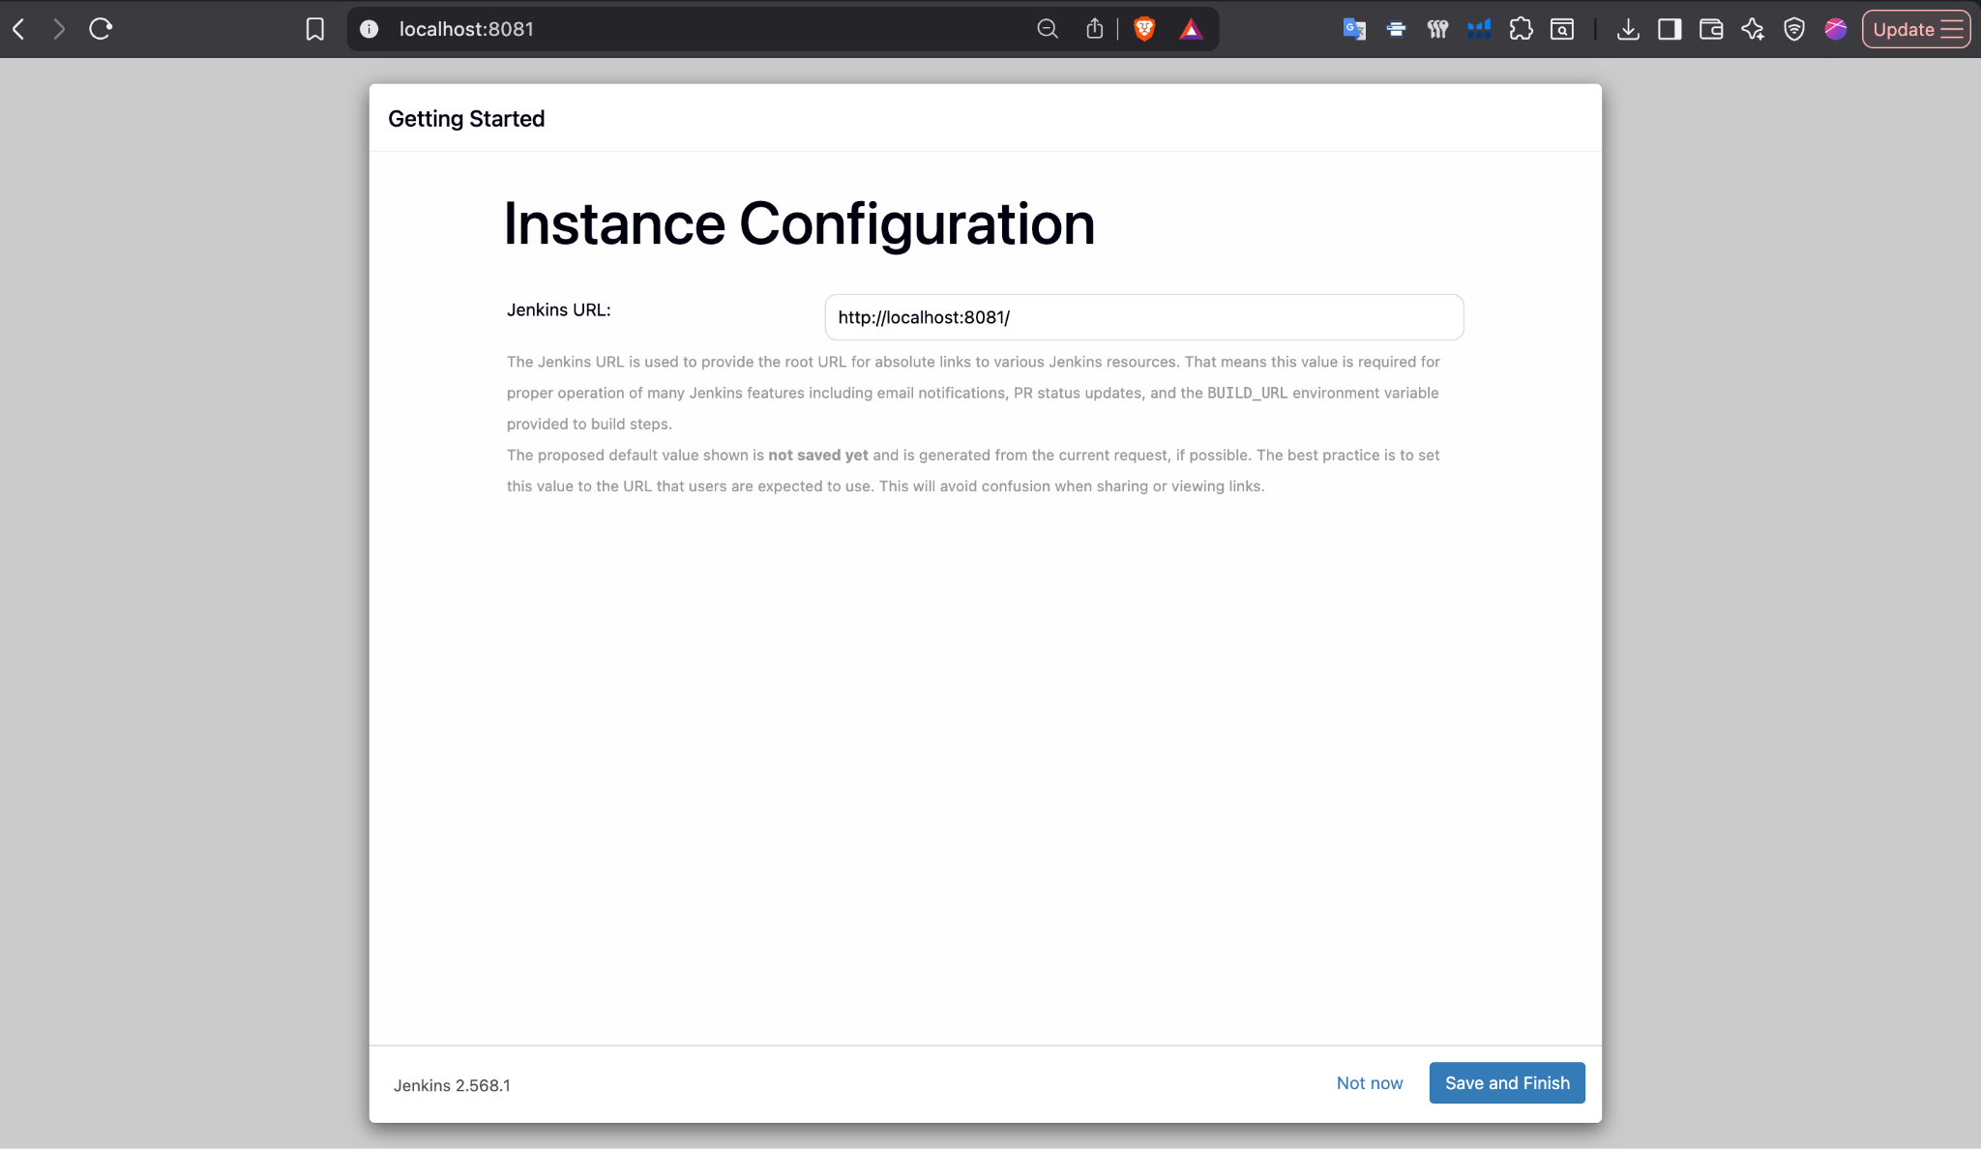
Save and finish.

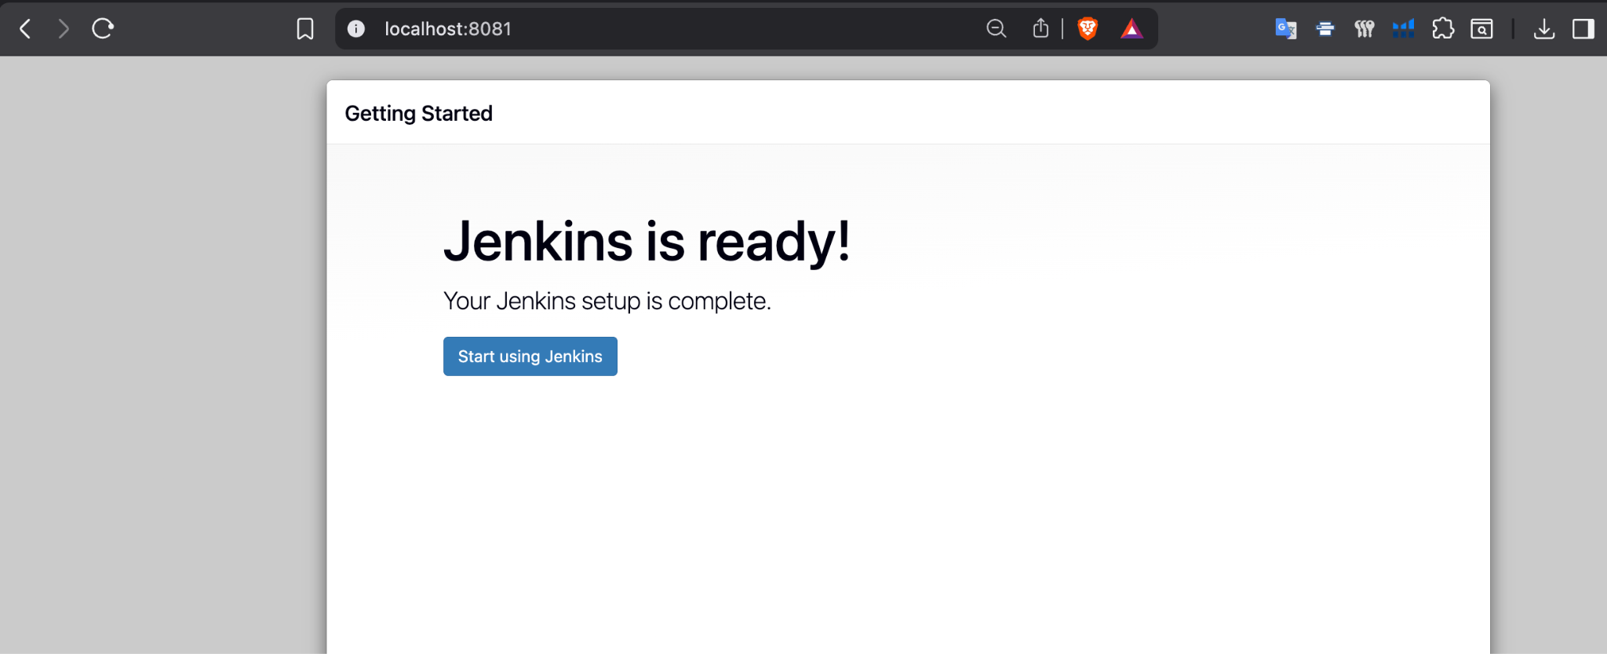
Start using jenkins.
Step 7: Access Jenkins Dashboard
Start Jenkins and verify that the dashboard loads successfully.
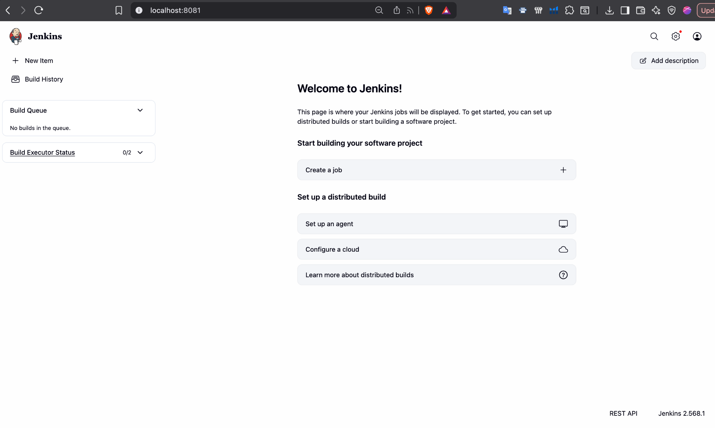
Step 8: Create Project Files
Create app.py, Jenkinsfile, test_app.py, and Dockerfile and push them to GitHub. for ex: demo Project
app.py

def add(a, b):
return a + b
def subtract(a, b):
return a - b
def multiply(a, b):
return a * b
if __name__ == "__main__":
print("Simp
le CI/CD Demo App")
print("2 + 3 =", add(2, 3))

Jenkinsfile
pipeline {
agent any
stages {
stage('Clone') {
steps {
echo 'Cloning repository...'
checkout scm
}
}
stage('Build') {
steps {
echo 'Installing dependencies...'
sh 'pip3 install --break-system-packages -r requirements.txt'
}
}
stage('Test') {
steps {
echo 'Running test cases...'
sh 'python3 -m pytest test_app.py -v'
}
}
}
post {
success {
echo 'Pipeline finished successfully!'
}
failure {
echo 'Pipeline failed. Check console output above.'
}
}
}

test_app.py
from app import add, subtract, multiply
def test_add():
assert add(2, 3) == 5
def test_subtract():
assert subtract(5, 2) == 3
def test_multiply():
assert multiply(3, 3) == 9
if __name__ == "__main__":
test_add()
test_subtract()
test_multiply()
print("All tests passed!")

Dockerfile
FROM python:3.9-slim
WORKDIR /app
COPY . .
RUN pip install --break-system-packages -r requirements.txt
CMD ["python3", "app.py"]
Now open jenkins http://localhost:8081/
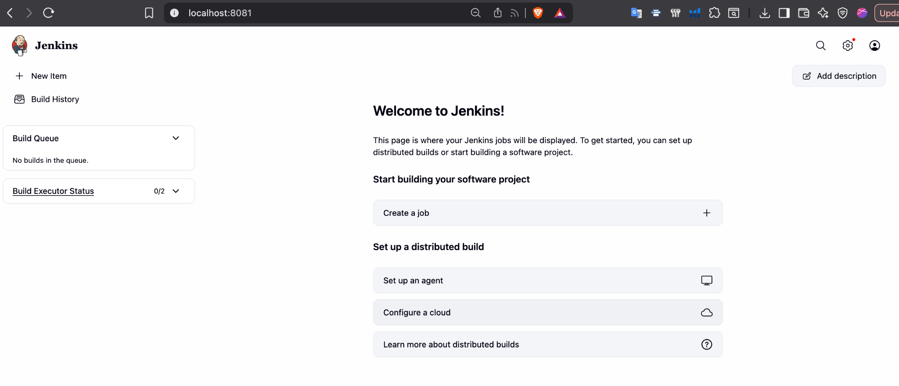
Click “New item” left side
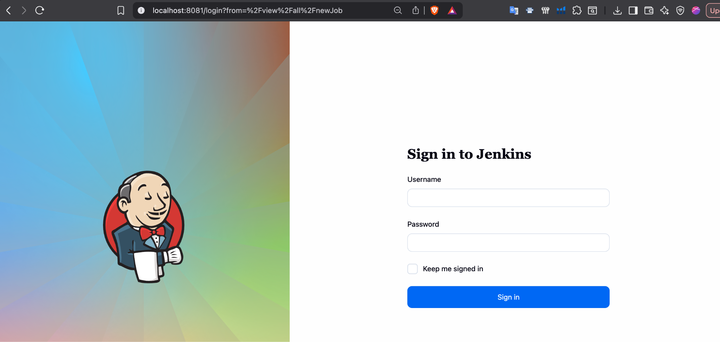
Step 9: Create Pipeline Job
Create a new Jenkins Pipeline project and configure it.
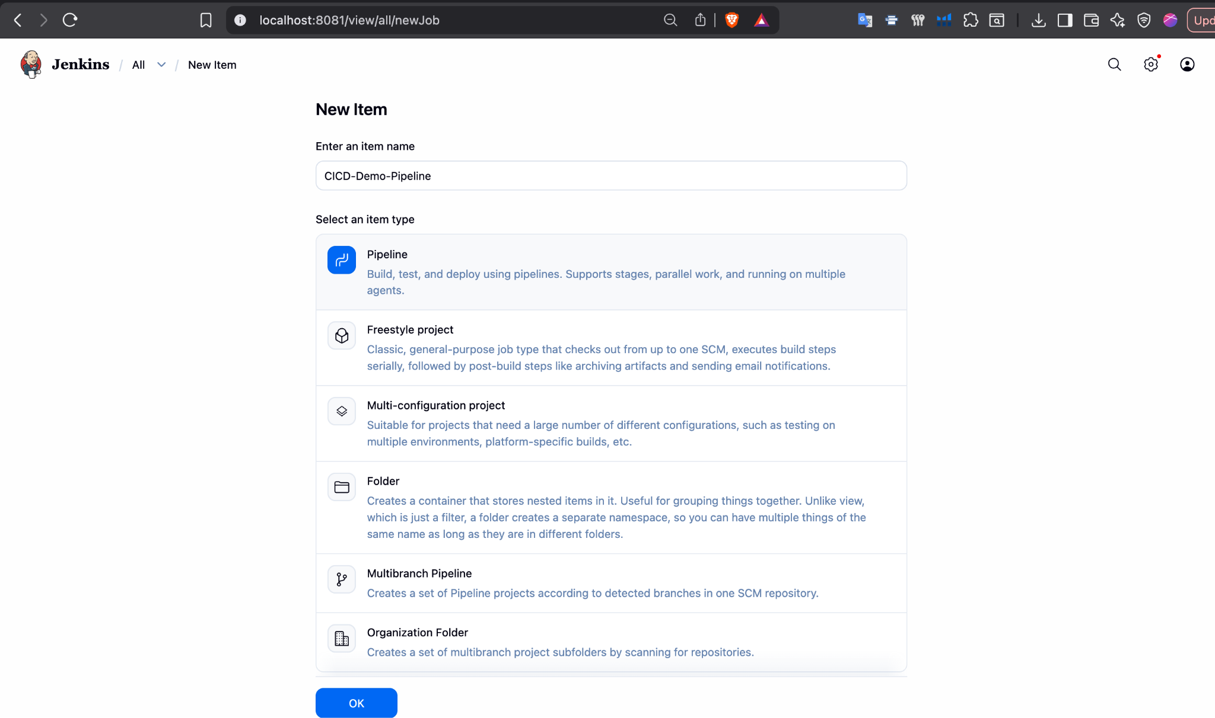
Step 10: Configure Git Repository
Configure Pipeline Script from SCM and connect the GitHub repository.

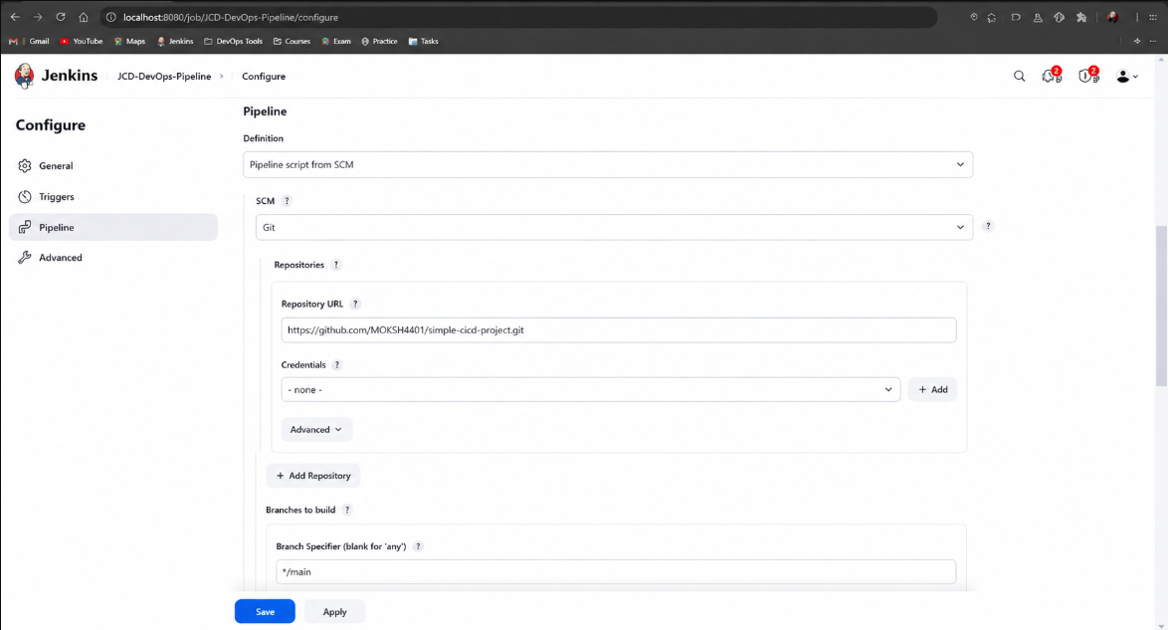

Scroll down and select “Pipeline script from SCM”. then SCM select “Git” then enter Github repository URL and in Branch “ */main ”
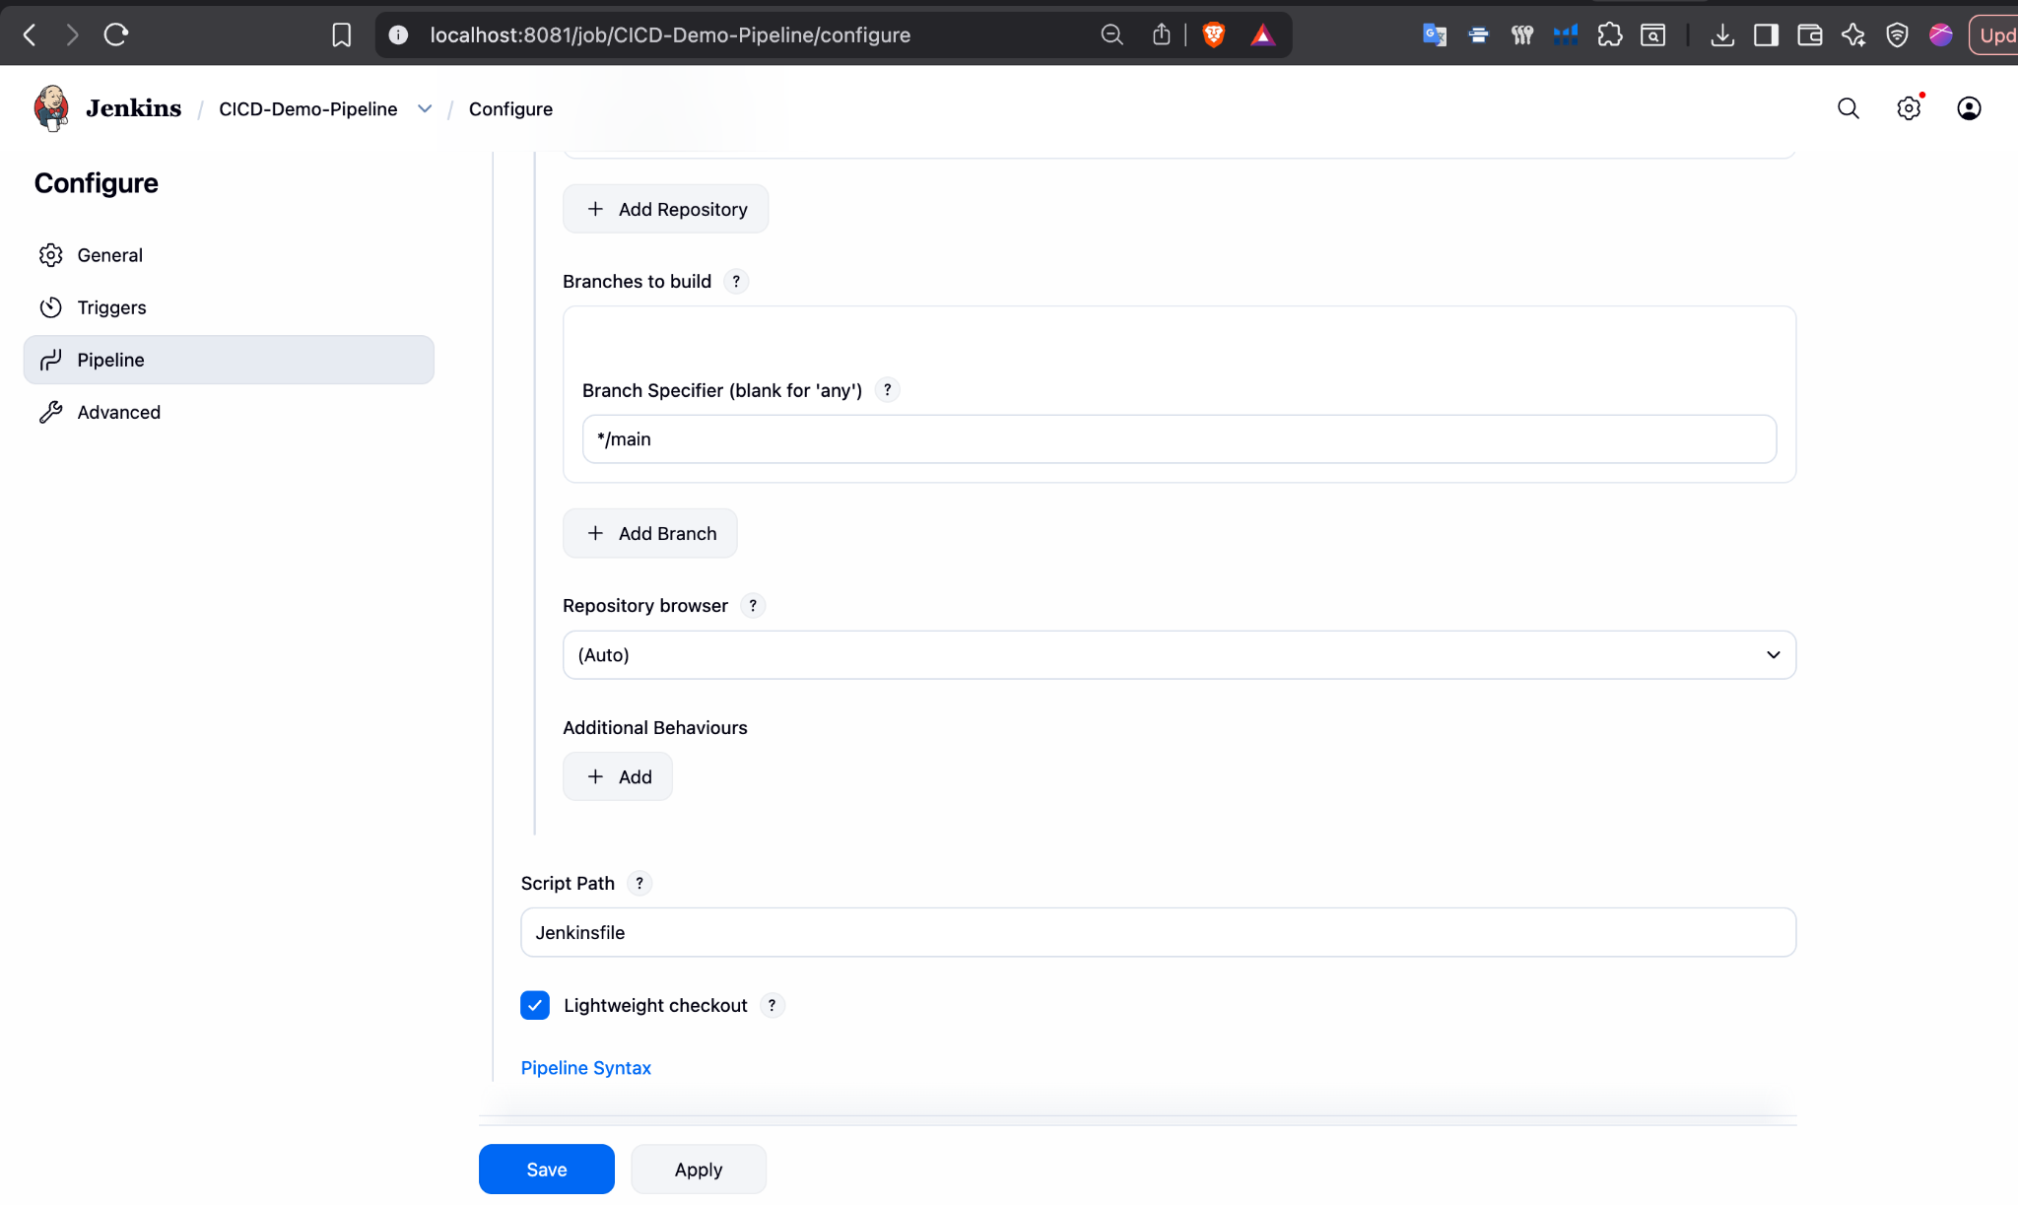
Final click on save
Update jenkins
docker exec -u root jenkins bash -c "apt-get update"
Step 11: Install Python in Jenkins
Install Python and pip inside the Jenkins container and verify the installation.
Install python:
docker exec -u root jenkins bash -c "apt-get install -y python3 python3-pip"

Verify installation :
docker exec jenkins python3 --version
docker exec jenkins pip3 --version

Step 12: Build the Pipeline
Run Build Now and monitor the pipeline execution.
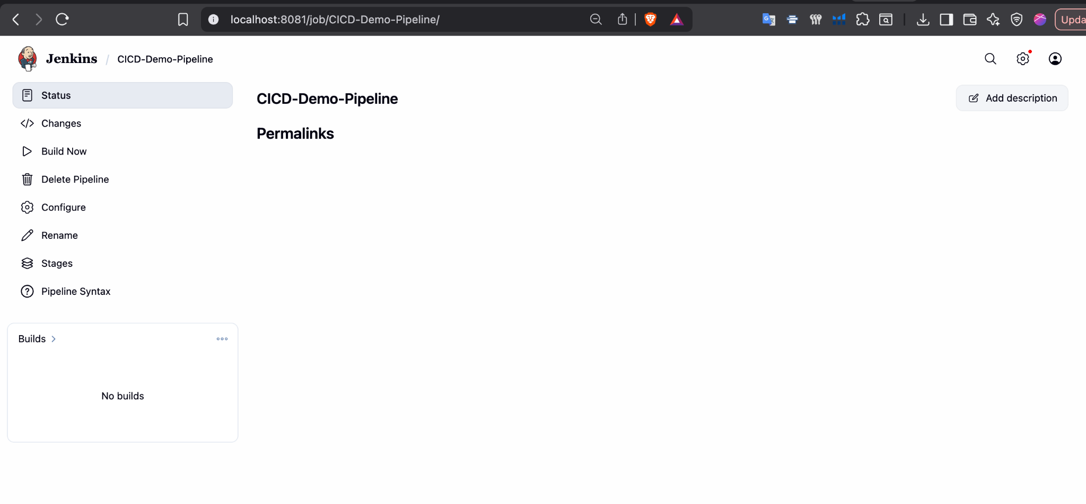
Pipeline is created successfully now click on “Build Now”.
Step 13: Verify Build Output
Check the console output and verify successful execution.
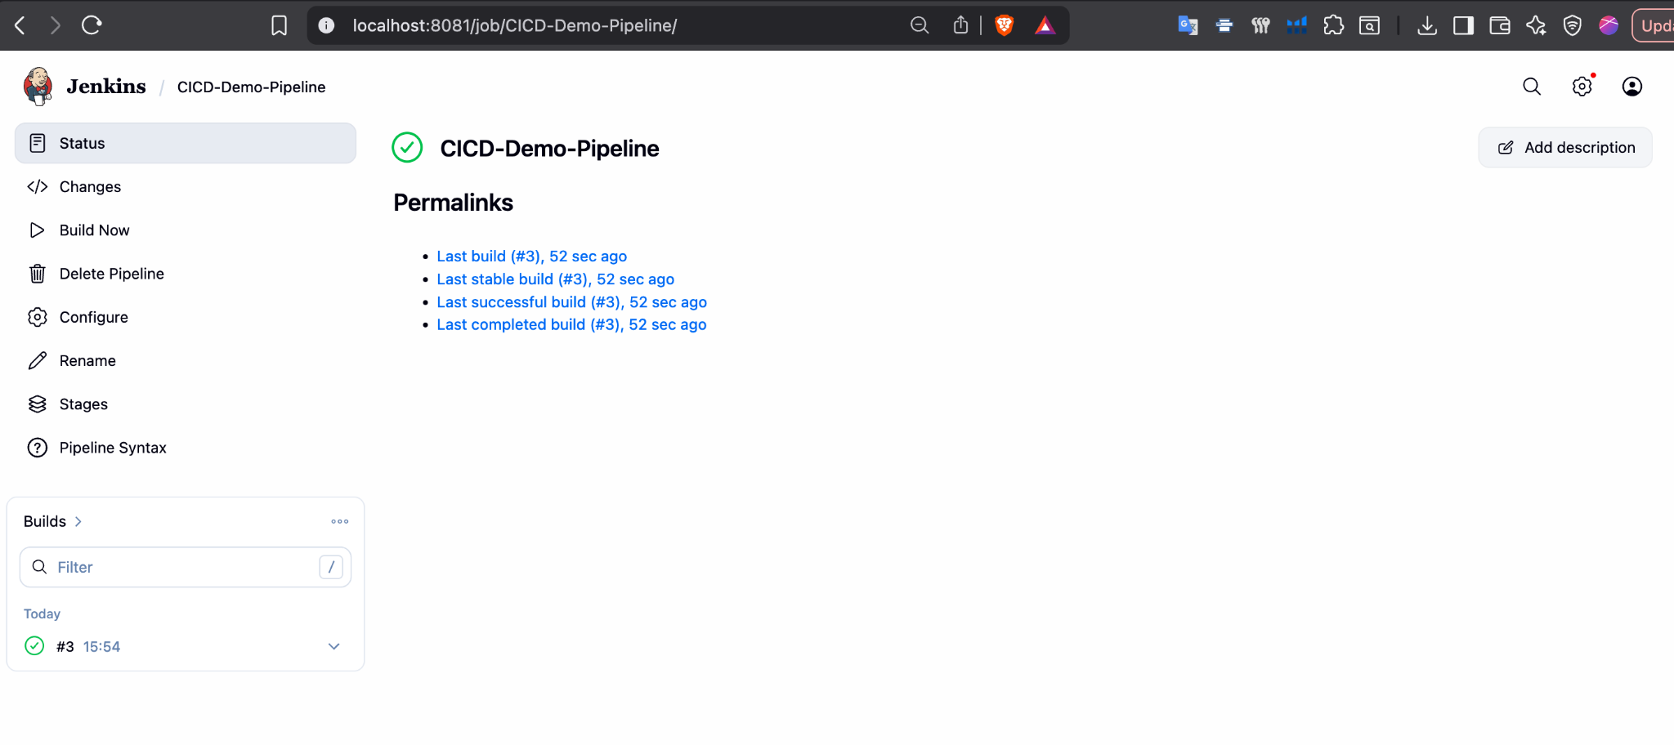
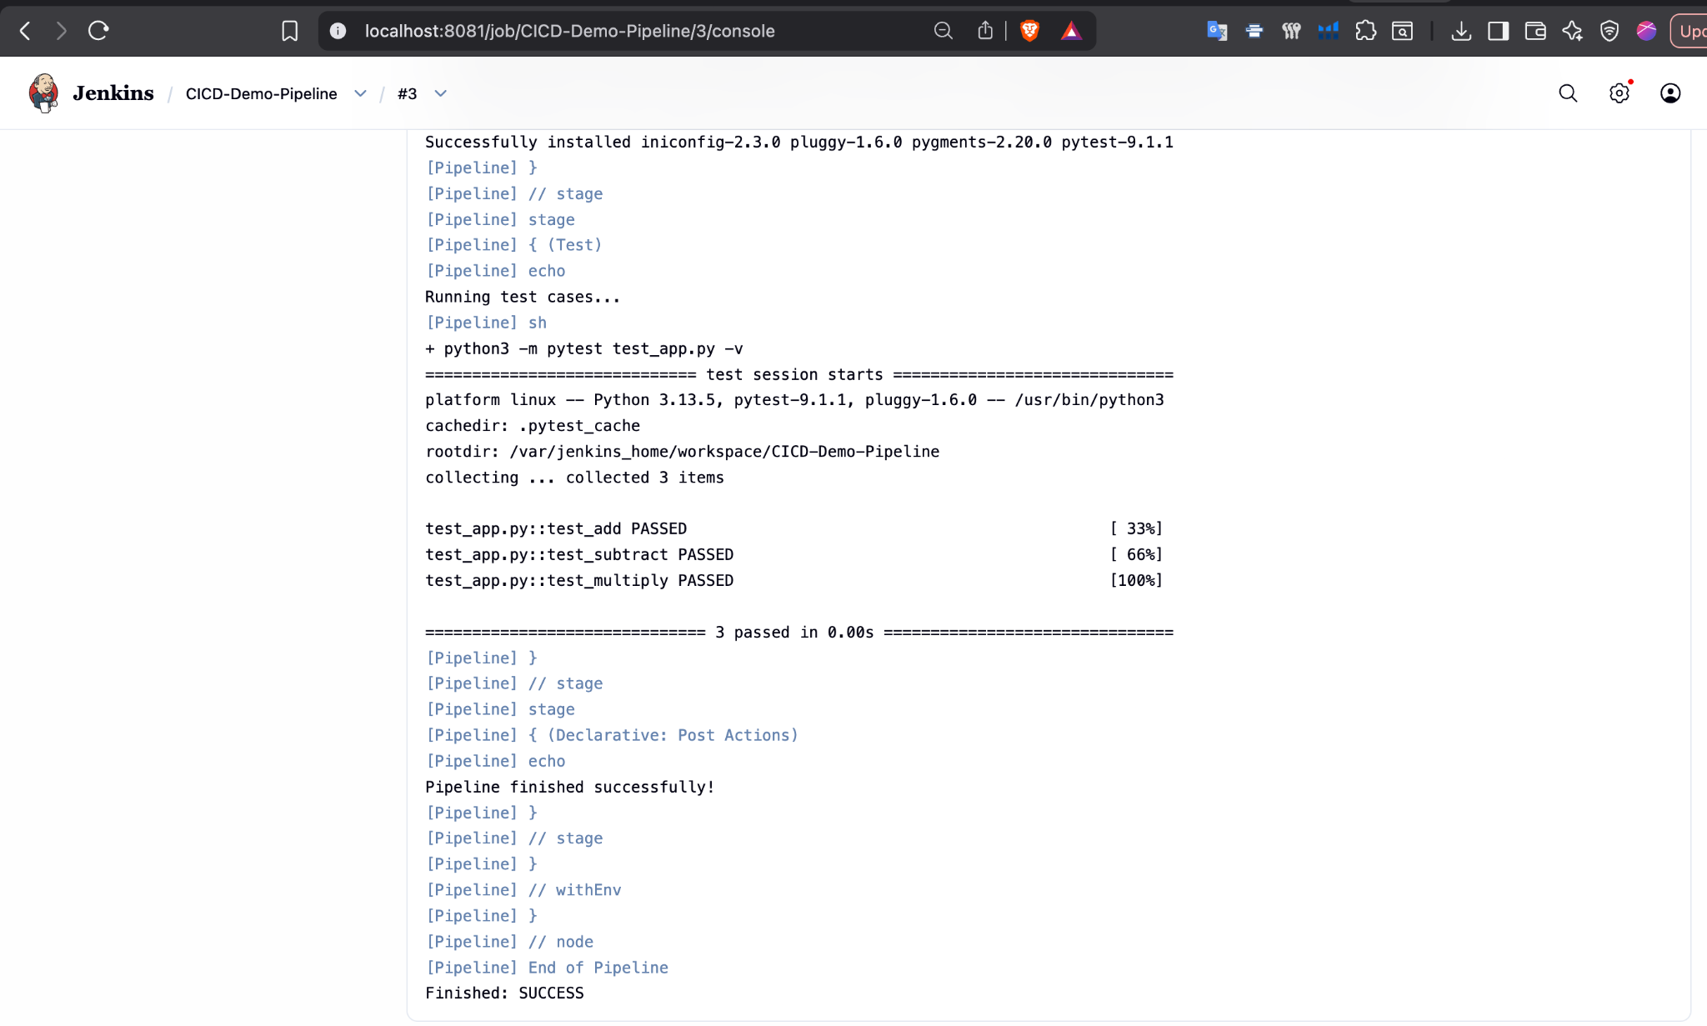
In console Output, you can able to see the Success message.
Step 14: Build and Run Docker Image
Build the Docker image and run the application container.
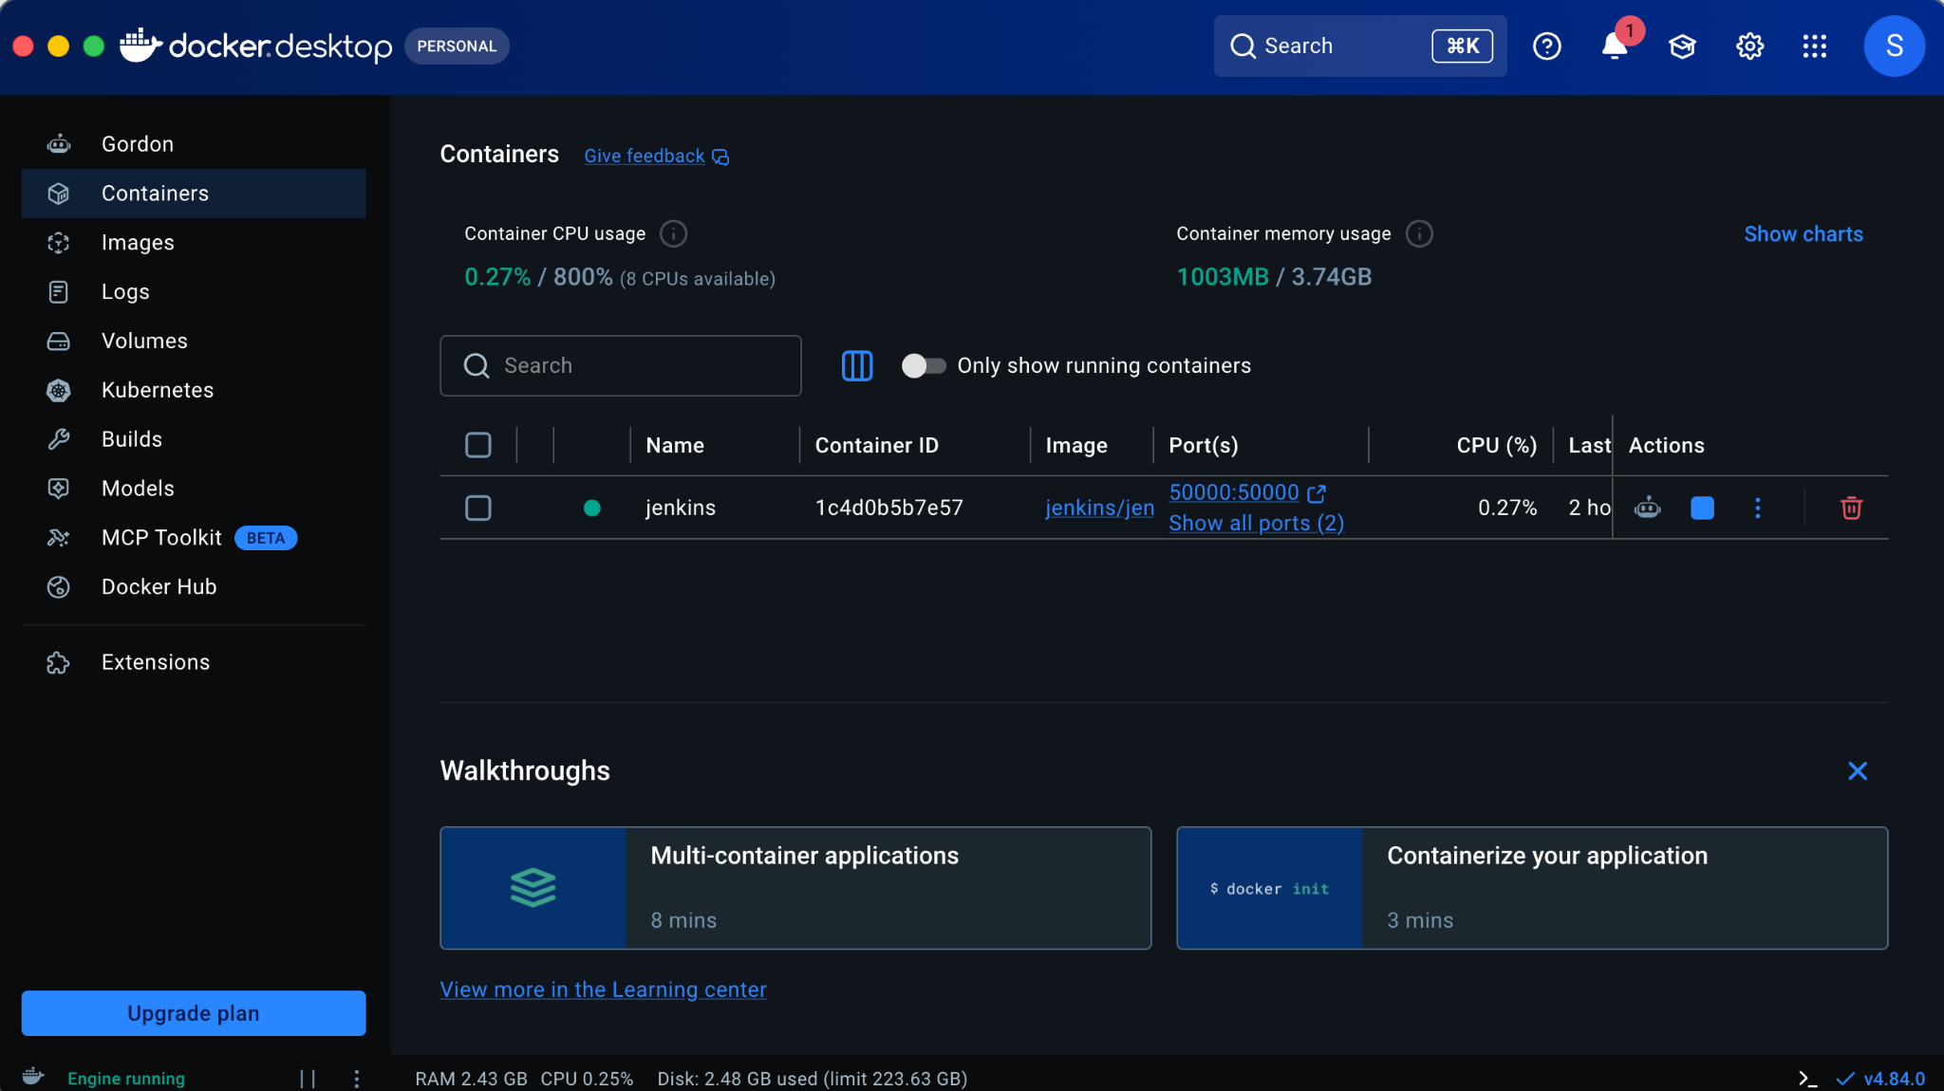

Now run the app in a docker container.
cd Desktop/Script4-CICD
docker build -t myapp .

docker run myapp
Reference Youtube Video:
https://www.youtube.com/watch?v=PKcGy9oPVXg

